- Log into the Census page here: https://entry.subst-abuse.uiowa.edu/IYS_Census/login.jsp
- If you do not know your username, click “What’s My User Name” and answer a series of questions.
- If you do not know your password, 1) Enter your User Name then 2) click “Forgot My Password”. An automated email containing your password will be sent to the email address associated with your IYS account.

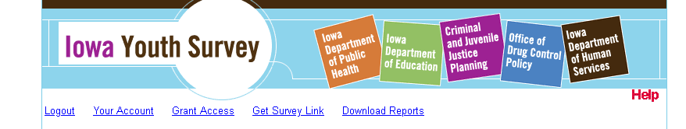
- Click “Download Reports” link at the top of the screen

- Select the report(s) you wish to download.

**If you wish to grant someone else access so that s/he may download the reports, please click “Grant Access” (circled in yellow). Then enter the email address of the person you wish to grant access on the next page. This individual will then get an automated email to set up an IYS account.
If you have any questions or concerns about downloading your report, please e-mail icsa-support@uiowa.edu or call 319-335-4603.

